**Year 8 Science**

**2022**

**Topic Test:**

**Particle Model, Kinetic Theory & Density**

**Name: ANSWERS Marks: 45**

**Teacher: _______________________**



**Materials Required:**

* **Blue/black ballpoint pen**
* **Pencil**
* **Ruler**
* **Eraser**
* **Calculator**

|  |  |  |
| --- | --- | --- |
| **Section 1**  **(10)** | **Section 2**  **(35)** | **Total**  **(45)** |
|  |  |  |

**Section 1: Multiple Choice [10 Marks]**

**Circle the letter of the most correct answer for each of the statements or questions below.**

1. The Kinetic Theory of Matter states that all matter is made up of

1. stationary particles
2. substances having no regular properties
3. gases and liquids which collide
4. small moving particles

2. To be called “matter”, a substance must have

1. shape and volume
2. solid, liquid and gaseous forms
3. mass and volume
4. chemical properties

3. When a liquid is poured from one container into a different container, which of the following will happen?

1. Its volume changes
2. Its shape changes
3. Its shape and volume changes
4. Its shape and volume does not change
5. Rank water, gold, and oxygen in order of how much their volume changes when heated (from expanding the most to the least).

1. Oxygen, gold, water
2. Oxygen, water, gold
3. Water, oxygen, gold
4. Water, gold, oxygen
5. Which of the following statements is not true for liquids?

1. The particles vibrate more rapidly than in a solid
2. A liquid has a definite volume
3. A liquid can be compressed
4. A liquid can flow and take the shape of its container
5. The recycling of aluminium can be considered as a series of physical changes as shown by the flow diagram below:

Which stages of the aluminium recycling process would be considered a change of state?

1. I and II
2. II and III
3. III and IV
4. Only III

7. Density is a measure of the total amount of mass of an object in a certain volume. Below are four 1 cm3 cubes of different metals.

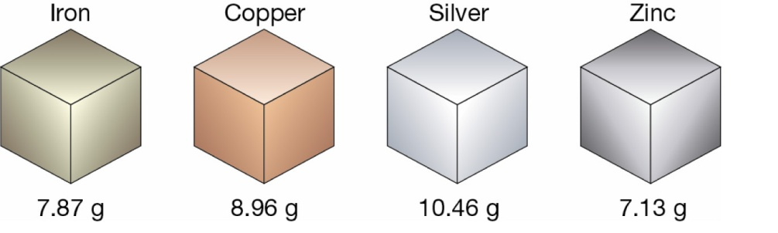

The metal with the lowest density is

1. iron
2. copper
3. silver
4. zinc

8. An object will float on top of a liquid if it is less dense than the liquid and sinks if it is more dense than the liquid. Four identical balls are dropped in four different liquids shown below. Which liquid is most dense?

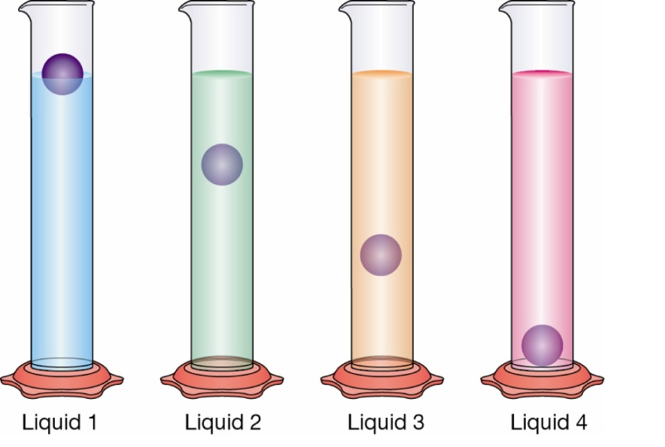

1. liquid 1
2. liquid 2
3. liquid 3
4. liquid 4
5. Which of the following is a chemical property?
6. Sawdust is produced from wood being cut by a power saw
7. Fireworks explode in a colourful light display
8. Water freezes to form ice
9. Juice is obtained from an orange
10. When heat is added to a substance, which of the following occurs?
11. Particles become more attracted
12. Particles get larger
13. Particles get smaller
14. Particles move faster

**End of Section 1**

**Section 2: Short Answers [35 Marks]**

**Answer ALL questions in the spaces provided below. Use a blue or black pen unless you have been asked to draw a diagram.**

**Question 11 [6 Marks]**

Select a term from those in the box below that best matches each of the statements in the table. Cross out the words as you go, as some terms will **not** be used.

|  |
| --- |
| **density ; solid ; hardness ; boiling point ; diffusion ; gas ; compressibility ; carbon dioxide; melting point; evaporation ;** |

|  |  |
| --- | --- |
| **Statement** | **Term** |
| a. a substance that undergoes sublimation | **Carbon dioxide** |
| b. the temperature at which a solid changes into a liquid when heated is called its ­­­­­­­­­________________. | **Melting point** |
| c. a type of matter that has fixed volume and a definite shape | **Solid** |
| d. the natural spreading of particles from an area where they are highly concentrated to an area of low concentration | **Diffusion** |
| e. the state of matter in which particles have the highest kinetic energy | **Gas** |
| e. the ability of a substance to scratch another substance | **Hardness** |

**Question 12 [6 Marks]**

a. Complete the table below by drawing a simple illustration to show the Particle Model of the three states of matter inside a container. You do not need to ‘fill’ the whole container. (3 marks)

|  |  |  |
| --- | --- | --- |
| **Solid** | ngle,Area,Cylinder PNG Clipart - Royalty Free SVG / PNG**Liquid** | **Gas** |
| ngle,Area,Cylinder PNG Clipart - Royalty Free SVG / PNG |  | ngle,Area,Cylinder PNG Clipart - Royalty Free SVG / PNG |

b. Briefly describe **how the particles are positioned** and **how they move** in each of these states. (3 marks)

Solid:

**Particles are in fixed position (1/2).**

**Particles vibrate on the spot (1/2).**

Liquid:

**Particles are close together, but not tightly packed (1/2).**

**Particles can slide past one another (1/2).**

Gas:

**Particles are spaced apart (1/2).**

**Particles move in all directions (1/2).**

**Question 13 [10 Marks]**

Use the formula shown below to calculate the density of each of the objects described. Set your work out clearly, showing the formula you are using for each calculation and include appropriate units with your answer.

|  |
| --- |
| **Density of an object:** **Volume of a rectangular prism:**  Density = mass ÷ Volume Volume = length x width x height |

a. (i) 25 mL of an unknown liquid was measured in a measuring cylinder. The liquid has a mass of 23.25 g. Calculate the density. (**Include working out.)** (3 marks)

**23.25 / 25 (1 mark)**

Density = **0.93 g/mL (1 mark answer)**

**(1 mark units)**

(ii) Pure water has a density of 1 g/mL. Would this unknown liquid float or sink if it was added to a beaker containing pure water? (1 mark)

**Float (less dense than water)**

b. A rectangular block weighs 32 g. Its length, width and height are shown on the diagram.

1. Calculate the volume of the rectangular block. **Include working out.** (3 marks)

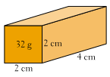

**4 x 2 x 2 (1 mark)**

Volume = **16 cm^3 (1 mark answer) (1 mark units)**

1. Find the density of the wooden block. **Include working out.** (3 marks)

**32 / 16 (1 mark)**

Density = **2 g/cm^3 (1 mark answer)**

**(1 mark units)**

**Question 14 [3 Marks]**

Fill in all the boxes on the diagram below by identifying the ‘states of matter’ and their phase changes.

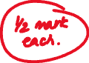

**Gas**

**Liquid**

**Solid**

**Question 15 [4 Marks]**

Explain the following with reference to particle theory:

* 1. Why does an inflated balloon burst when it is left in the sun? (2 marks)

**It absorbs heat and the temperature of the air inside it increases (1).**

**This causes the particles to move further apart (gas expands) causing the pressure to increase which bursts the balloon (1).**

* 1. Why a joint is included in railway tracks (like the one shown below) that allow the parts of the rail to move over one another if needed. (2 marks)

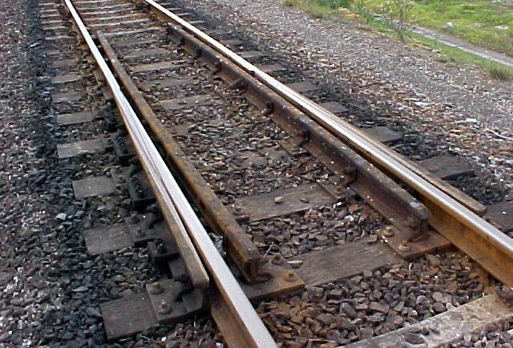

**In hotter temperatures (like summer), the rails will expand (1).**

**The joint allows the rails to move without bending or changing shape (1).**

**Question 16 [3 Marks]**

As shown in the diagrams below, gases are able to be compressed, whereas both solids and liquids are incompressible. Explain why.

**In gases, the particles are spread far apart and there are spaces between them (1) that allows the particles to be ‘squeezed’ or compressed so they are more closely packed (1).**

**The particles of solids and liquids are already tightly packed with little space between them so are unable to be compressed (1).**

**Question 17 [3 Marks]**

Matthew placed a beaker of ice on a bench. Every 30 minutes he measured the temperature of the ice water until the ice was completely melted.

Explain why the liquid inside the thermometer will rise as the beaker of ice melts.

**As the particles of the liquid in the thermometer are heated, they gain more kinetic energy (1). This causes them to move faster and spread further apart (1), resulting in expansion which pushes the liquid in thermometer to rise (1).**

**End of Test**